**Introduction to Cyber Security**

**Content Discovery**

**Task 1:**

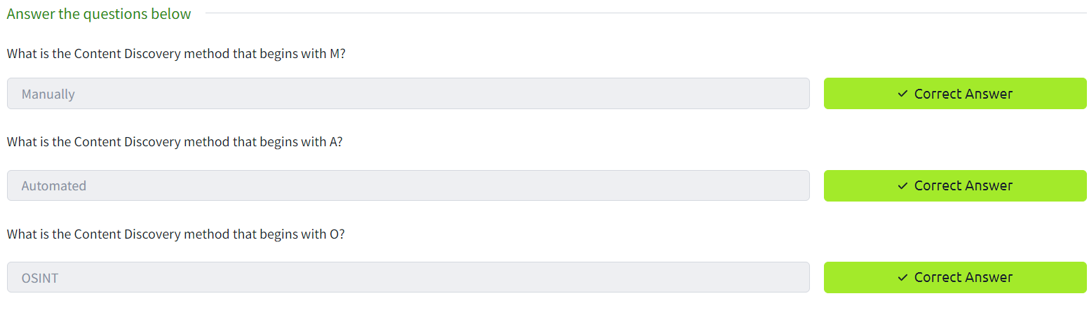

**Task 2:**

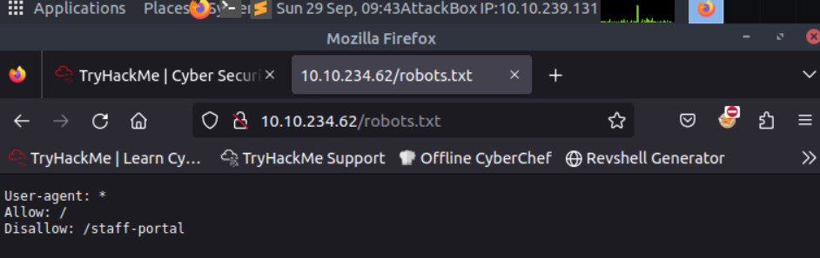

**Task 3:**

First goto this URL: <https://wiki.owasp.org/index.php/OWASP_favicon_database>.

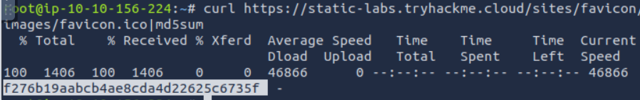

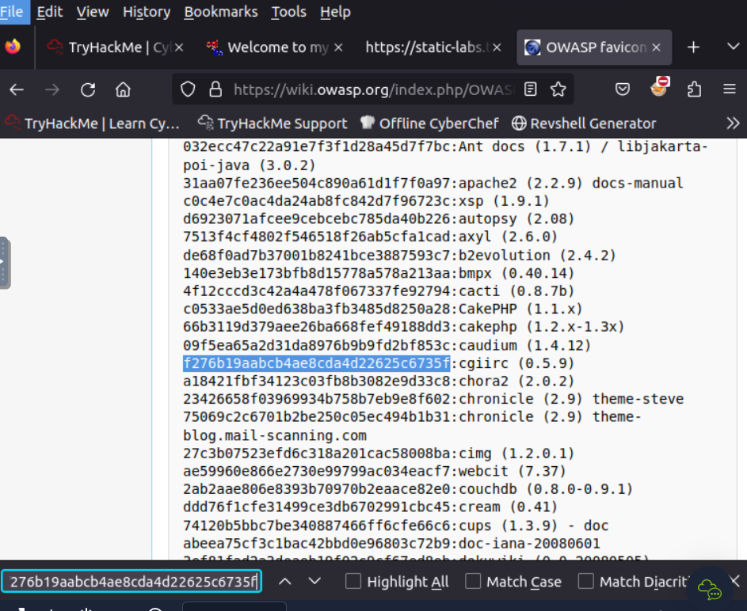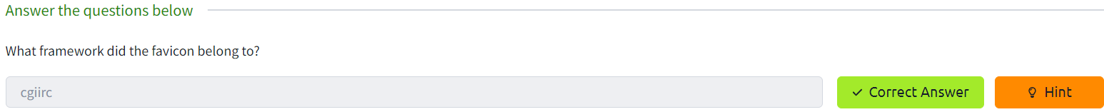

**Task 4:**

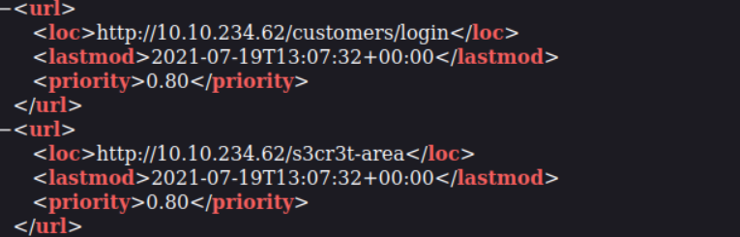

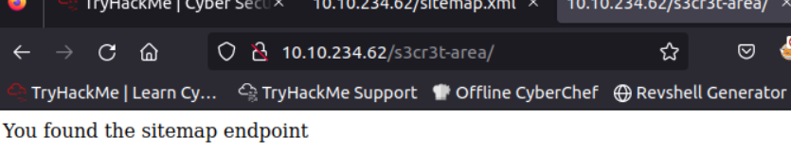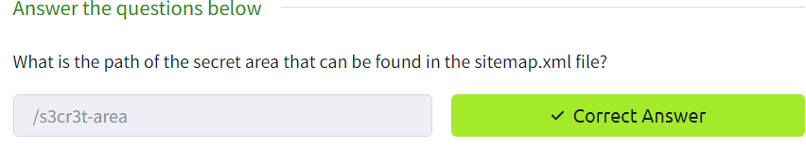

**Task 5:**

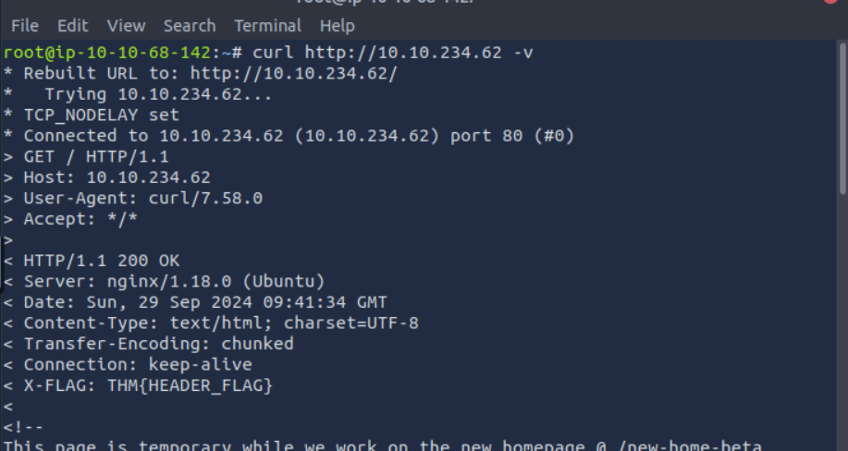

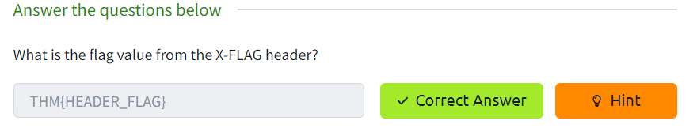

**Task 6:**

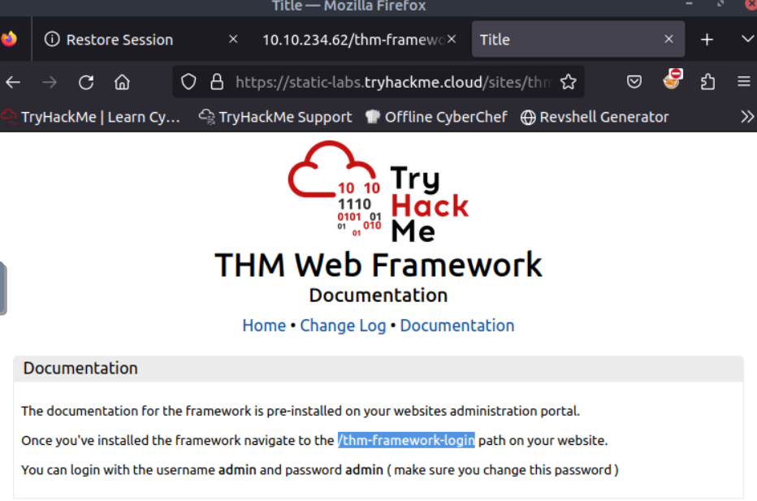

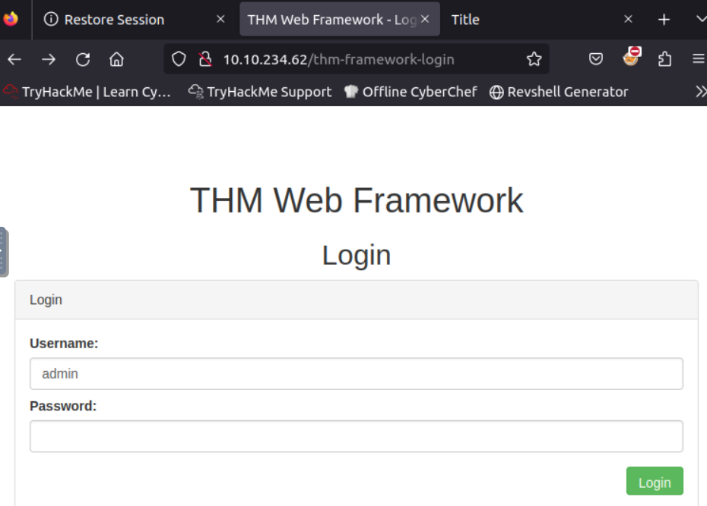

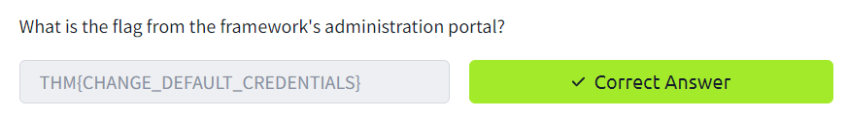

**Task 7:**

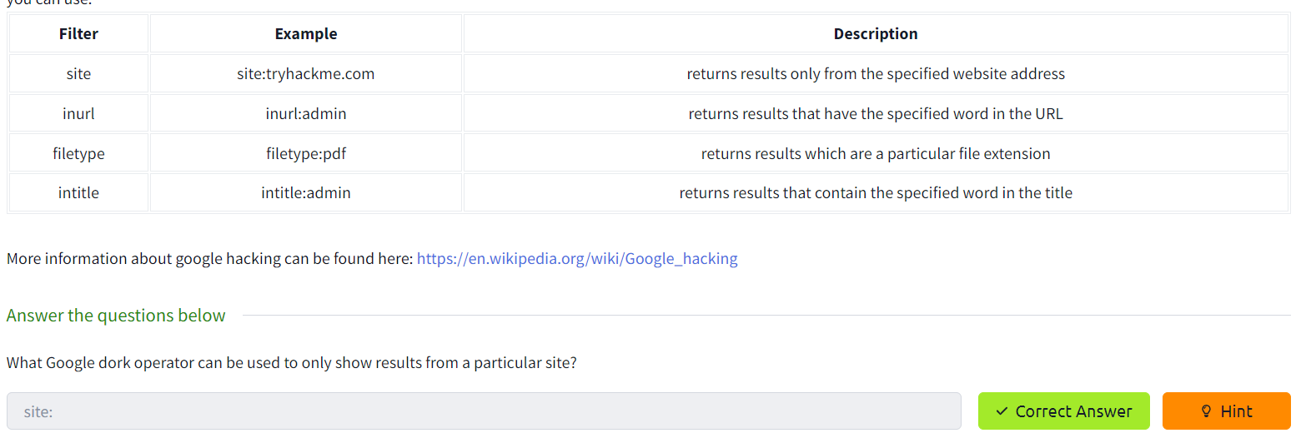

**Task 8:**

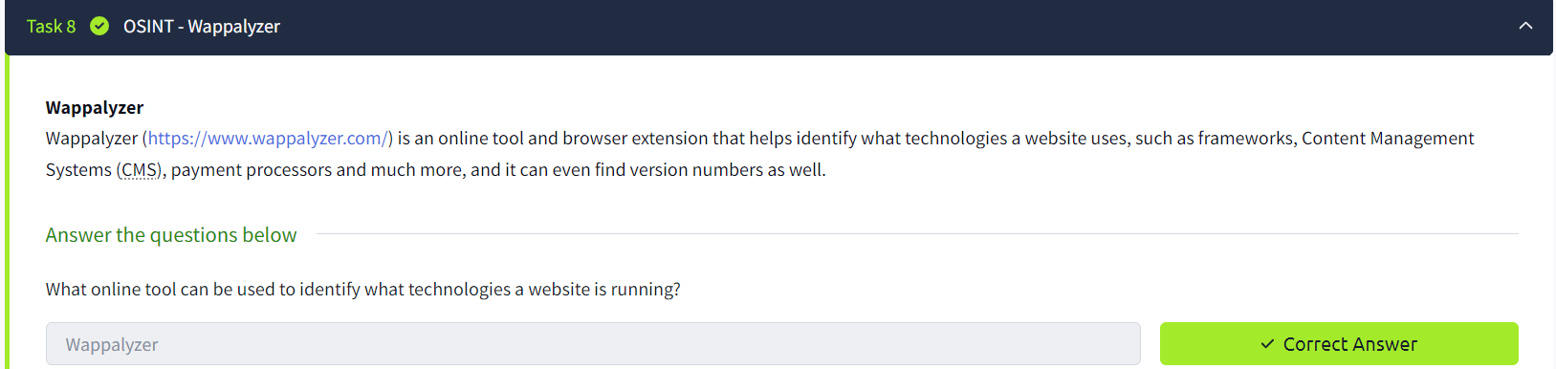

**Task 9:** <https://archive.org/web/>

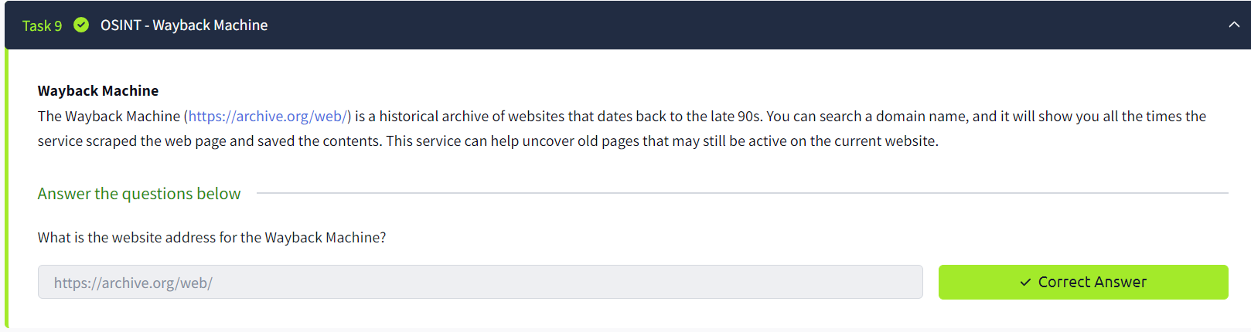

**Task 10:**

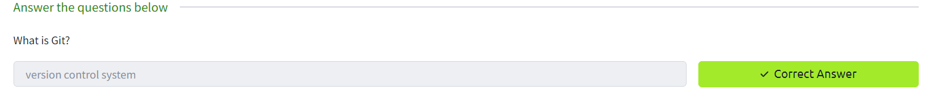

**Task 11:**

